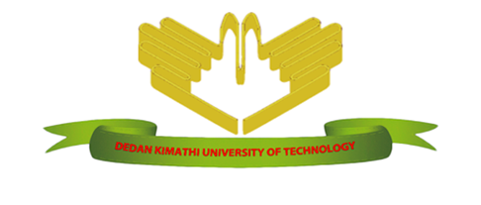

**DEDAN KIMATHI UNIVERSITY OF TECHNOLOGY**

SCHOOL OF COMPUTER SCIENCE AND INFORMATION TECHNOLOGY

DEPARTMENT OF INFORMATION TECHNOLOGY

PROJECT TITLE:

**SMART-IRRIGATION SCHEME SYSTEM**

BY:

KIPROTICH SETT CALEB

C025-01-1002/2017

SUPERVISOR: MRS. KURIA JANE

**Project documentation submitted to the Department of Information Technology in the school of computer science and Information Technology in partial fulfillment of the requirements for the award of the degree of BSc. in Information Technology at Dedan Kimathi University of Technology**

**JANUARY, 2021**

# DECLARATION

I declare that this is my original work and has not been presented in any University for a degree or for any consideration of any certification.

Student: **Kiprotich Sett Caleb** Sign: ….……………… Date…………………

This proposal document has been submitted with my approval as the university supervisor

**MRS. JANE KURIA** Sign…………………………. Date………………………

Department of Information Technology.

# DEDICATION

I dedicate this research project to my friends and family, my colleagues in the university and more importantly to my able supervisor Mrs. Jane Kuria. However, how vital this research project entails, special dedication also goes to the famers in the field who do their best to achieve superb results in crop farming.

# ABSTRACT

The agriculture endures to play a vital part in the rural economy. Agriculture has been the key to Kenya's economy, contributing 26 per cent of the Gross Domestic Product (GDP). Agriculture in itself is also a market for industrial goods such as machinery, equipment and fertilizers used in the farming process.

Agricultural activities in our country or even outside have significantly and primarily depended on the rain as the main source of water for their crops. Rain has attested to be an insufficient source and has also lacked predictability and thus requiring farmers to opt for irrigation which also has not been effective and efficient. Farmers have faced water utilization constraints, low crop productivity and tedious work load on the same irrigation.

This research project aims at establishing an automated irrigation system to be used at different crop farming schemes. The system is obliged to use a GSM technology tool, a Direct-Current immersible motor, soil moisture and water level sensor and a microcontroller to monitor the soil moisture content and the water level in the irrigation reservoirs. The GSM modem will be configured using. Attention (AT) commands so that there is a real-time monitoring of the farm remotely. The farm is dynamically monitored using this Irrigation System.

Here, a method of gathering necessary requirements is very vital. For this case, the following methods of gathering data will be used; Observation, Questionnaires and interviews. On the other hand, software Development method plays a very important role to the success of this project. In this regard, I will use **Agile development model.**

# ACKNOWLEDGEMENT

I thank God for having taken me through the three-year period successfully. The efforts of my teachers and trainers in school cannot go unrecognized for giving me the chance and knowledge that has helped me a lot. Finally, are the colleagues and my supervisor (Mrs. Jane Kuria) at Dedan Kimathi University of Technology whom together we have worked and have helped me gain the needed experience in the field for this period.

Contents

DECLARATION ii

DEDICATION iii

ABSTRACT iv

ACKNOWLEDGEMENT iv

CHAPTER ONE 1

INTRODUCTION 1

1.1 Background of the study 1

1.2 Statement of the problems 3

1.3 Purpose of the study 3

1.4 Objective of the research Project 4

1.4.1 Main/General objective 4

1.4.2 Specific objectives 4

1.5 Research scope 4

1.6 Assumptions 4

1.7 Limitations 5

1.8 Significance of the study 5

CHAPTER TWO 6

LITERATION REVIEW 6

2.1 Introduction 6

2.2 Case study one -Solar-Powered Irrigation System 6

2.3 Case study two- Drip-Irrigation System 7

2.4 Case study three-Automatic-irrigation using Solenoid Valves 9

2.5 Case study four- Automatic Sprinkler irrigation system 11

2.6 Research Gap 12

2.7 Conceptional Framework 12

CHAPTER THREE 14

RESEARCH METHODOLOGY 14

3.1 Introduction 14

3.2 Research Design 14

3.3 Data Collection Methods 15

3.3.1 Questionnaires 15

3.4.2 Interviews 17

3.4.3 Observation 17

3.4 Software Development Method 18

3.4.1 Introduction 18

3.4.2 Agile development cycle 18

3.5 Justification for Methodology 20

3.6 Ethical Considerations 20

CHAPTER FOUR 22

SYSTEM ANALYSIS AND DESIGN 22

4.1 Introduction 22

4.2 Feasibility analysis 22

4.2.1 Technical Feasibility 22

4.2.2 Economic Feasibility 22

4.2.3 Scheduling Feasibility 23

4.2.4 Operational Feasibility 23

4.3 Requirement Analysis 23

4.3.1 Functional Requirements 23

4.3.2 Non-Functional Requirements 23

4.4 Data Analysis 24

4.4.1 Questionnaire 24

4.5 Design 27

4.5.1 Flow Chart 27

4.5.2 Block Diagram 28

4.5.3 Sequential Diagram 29

4.5.4 Data Flow Diagram(DFD) 30

4.5.5 Use case Diagram 31

4.5.6 Circuit Diagram 32

CHAPTER FIVE 33

SYSTEM IMPLEMENTATION AND TESTING 33

5.1 Introduction 33

5.2 System Test Plan 33

5.3 Test Plan 33

5.3.1 Unit Testing 33

5.3.2 Integration Testing 33

5.3.3 Acceptance Testing 33

5.4 Test Cases 33

5.4.1 Automatic Page 34

5.4.2 Manual Page 35

5.5 System Implementation 36

5.5.1 Collection of data 36

5.5.2 Implementation Strategy 36

REFERENCES 37

APPENDICES 38

A.1 RESOURCES 38

A.2 SCHEDULE 38

A.3 BUDGET 40

Lists of Tables

Table 1. Time Schedule for the project……………………………….31

Table 2 Gannt Chart…………………………………………………...32

Table 3 Budget…………………………………………………………33

Figure 1 Agile Development Methodology 19

Figure 2 Questionnaire 1 24

Figure 3 Questionnaire 2 24

Figure 4 Figure 4 Questionnaire 3 25

Figure 5 Figure 4 Questionnaire 4 25

Figure 6 Flow Chart 27

Figure 7 Block Diagram 28

Figure 8 Sequential Diagram 29

Figure 9 Data Flow Diagram 30

Figure 10 Use Case Diagram 31

Figure 11 Circuit Diagram 32

Figure 12 Automatic Page 34

Figure 13 Manual Page 35

# CHAPTER ONE

# INTRODUCTION

## 1.1 Background of the study

The agriculture has continued to play a very vital role in the rural as well as urban economy. Agriculture is the key to Kenya's economy, contributing 26 per cent of the Gross Domestic Product (GDP) and another 27 per cent of GDP indirectly through linkages with other sectors. The sector employs more than 40 per cent of the total population and more than 70 per cent of Kenya's rural people. Agriculture in Kenya is large and complex, with a multitude of public, parastatal, non-governmental and private sectors.

The sector accounts for 65 per cent of the export earnings, and provides the livelihood (employment, income and food security needs) for more than 80 per cent of the Kenyan population and donates to improving nutrition through production of safe, diverse and nutrient dense foods. The sector is also the min driver of the non-agricultural economy including manufacturing, providing inputs and markets for non-agricultural operations such as building/construction, transportation, tourism, education and other social services.

The dynamics of poverty in Kenya are changing and is directly influenced by the country's agriculture. Currently 46 per cent of the population live on less than 1 USD a day, 36.5 per cent are food insecure and 35 per cent of children under five are stunted (chronically malnourished) in Kenya. The country's population has increased significantly. As a result of this rapid increase, land parcels in the areas of high agricultural potential are decreasing in size, affecting food production.

Farmers, who are used to rain-fed farming systems, are being pushed into dryer, more marginal areas where they become increasingly vulnerable to drought and the unpredictability of weather patterns resulting from climate change. The population increase, coupled with the expansion of agriculture into arid lands, has affected the dynamics of pastoralism, where increased competition for natural resources has sparked escalated conflict in some areas. Furthermore, there has been a marked increase in the number of people dropping out of the nomadic livelihood, often moving into settled communities which are heavily reliant on food aid. Given the importance of agriculture in rural areas of Kenya where poverty is prevalent, the sector's importance in poverty alleviation cannot be overstated.

Strengthening and improving the performance of the agricultural sector and enabling the engagement of the poorest and most vulnerable in this process is therefore a prerequisite and a necessary condition for achieving recovery and growth in Kenya after recent years of drought a slow development.

Global warming is the slow increase in the average temperature of the earth’s atmosphere because an increased amount of the energy (heat) striking the earth from the sun is being trapped in the atmosphere and not radiated out into space.

The earth’s atmosphere has always acted like a greenhouse to capture the sun’s heat, ensuring that the earth has enjoyed temperatures that permitted the emergence of life forms as we know them, including humans. Without our atmospheric greenhouse the earth would be very cold. Global warming, however, is the equivalent of a greenhouse with high efficiency reflective glass installed the wrong way around.

One of the effects of global warming is the dryness of soil in plantation. Increased in temperature will caused the soil to become very dry and not suitable for agricultural activities. As a result, there will be plants' malnutrition, as the nutrients come from the microbial activities in the soil. Microbial activities will slowly decrease with increase in temperature. Thus, soil moisture is important for forecasting both temperature and precipitation. As the temperature rises the evaporation rate of soil moisture increases. The increased soil moisture evaporation helps cool the ground. On the other hand, soil moisture is a crucial variable in environment and climate systems. It has great impacts on agricultural and hydrological processes, and acts as a key role in agricultural.

Furthermore, people in urban area tend to grow plants in pots and basins on their balconies but due to their busy schedule they do not have time to take care of their garden. Because of that, people tend to water their plant in untimely manner.

Sometimes, people tend to water the plants more than they require. Too little water as well as too much water will be harmful for the plants. If the soil is too dry, plants are unable to develop and become susceptible to damage from pests. On the other hand, if the soil too wet, the plants are prone to get rots and other diseases. Besides, plants need specific amount of water to grow, reproduce and photosynthesis. Thus, this proposed system will reduce time and energy of the user in maintaining their farm.

This system will mainly be monitoring the water intake of the plants by measuring the water content in soil using the soil moisture sensor. The moisture level obtained from the sensor is matched with the value that has been set in the Arduino. If the moisture content is low, the Arduino will give a command to water the plant and vice versa. The water will stop until the sensor reading reached the specified programmable value for the farm soil. Therefore, this technology helps to report directly to the user in an easy way to understand format through their cellular phone.

## 1.2 Statement of the problems

We all depend largely on agriculture. There are most common challenges that farmers encounter in irrigation. In this research there are concerned factors such as the use of electricity appropriately as well as water supply and a suitable schedule or time for irrigating crops.

Farmers have found it difficult to meet these standards, more importantly where poverty is prevalent. Farmers have experienced budget constraints where the bills go beyond their friendly estimated values due to uncontrolled irrigation, excessive usage of electricity and the wages or salaries that can be paid to laborers who might have offered their time and energy to do irrigation. All these features make these research sustainable options to be considered to improve the agricultural activities and irrigation efficiency and effectiveness.

## 1.3 Purpose of the study

This study aims at discovering and developing a smart automated irrigation system that will work to control the amount of water used in irrigation by monitoring the soil moisture content and ensure correct irrigation schedule/time in order to enhance efficiency and effectiveness in agriculture activities.

## 1.4 Objective of the research Project

### 1.4.1 Main/General objective

The main objective of this project is to develop an automated irrigation system that will work to ensure effectiveness, efficiency and smoothness in irrigation and agriculture.

### 1.4.2 Specific objectives

By the end of this project the system should be able to:

1. Sense the Soil Moisture Content.
2. Start to irrigate plants when soil moisture content is below the agricultural value.
3. Stop irrigating plants when the soil moisture content is above the agricultural value
4. Show the percentage value of the moisture content, Pump status and time on the screen and allow farmer to manually turn on and off pump on.
5. Allow the farmer to Turn the system on and off through SMS via GSM module.

## 1.5 Research scope

This research entails the development of a system that looks into monitoring the water intake of the plants by measuring the water content in soil using the soil moisture sensor. The moisture level obtained from the sensor is matched with the value that has been set in the Arduino. If the moisture content is low, the Arduino will give a command to water the plant and vice versa. The water will stop until the sensor reading reached the specified programmable value for the farm soil.

This research also focuses on how this system includes and use sensor to detect and give the output i.e the moisture content of the soil with respect to the crop environment.

## 1.6 Assumptions

1. All the farmers have smart phones devices.
2. There is installed electricity or solar in every farmers’ household.

## 1.7 Limitations

1. It is expensive to maintain
2. Network connection may not be reliable
3. May require some knowledge to use some parts of the system

## 1.8 Significance of the study

The significance of the study is to develop an agricultural system that will aid farmers in their irrigation and help them manage their farms from far.

# CHAPTER TWO

# LITERATION REVIEW

## 2.1 Introduction

A literature review represents a general summary of previous researches done on the current topic at hand. This information is gotten from quite a number of sources which include, books, journal and websites including articles. Each case will give a comprehensive description of a previous research related to this research. After these cases, there is a research gap which will address issues like what is missing and what needs to be improved.

## 2.2 Case study one -Solar-Powered Irrigation System

Farmers have always played a significant role in our society as they provide the world’s population with food. However, one may forget that, not only do they provide food but they also provide energy, which nowadays, is of paramount importance, especially as in light of renewable energies. Indeed, farmers can produce energy from the wind, the sun or the biomass and they can use it for their own farm, or, if they have a surplus, resell it to companies.

Solar energy might be one of the easiest ways for farmers to produce energy. Indeed, farmers usually have several large buildings whose roofs are directly under the sun, without being hindered by the shadows of the trees, turning them into an ideal place to settle a photovoltaic system. Therefore, the use of solar energy in agriculture is becoming increasingly popular and the energy produced from this renewable source can be used either on the farm or in the local power grid, providing the farmer with an additional income.

One of the areas in agriculture that benefits the most from solar energy is irrigation, especially in arid regions. The main reason is that using the sun for irrigation represents a virtuous circle: when the sun shines, it feeds the irrigation system, well, we know that crops need more water when the sun shines a lot. Therefore, a large quantity of energy is available when it is actually needed.

**How it works:**

The pumps used for the transport of the water are equipped with solar cells. The solar energy absorbed by the cells is then converted into electrical energy via a generator which then feeds an electric motor driving the pump. Most of the traditional pump systems mainly work with a diesel engine or with the local power grid. However, these two modes of operations present disadvantages compared to solar pumps.

In many rural areas, especially in developing and emerging countries, the access to the electricity grid is not always guaranteed. In this case, farmers cannot rely on the traditional irrigation system. Thus, using an independent and alternative energy system can be a solution for the farmer to secure a safe power source and for the public grid to avoid saturation.

Diesel pumps are slightly more efficient than AC powered pumps as they allow greater flexibility. However, one of the main constraints is that this system relies on the fuel availability, added to a greater impact on the environment. Diesel-driven pumps are cheaper than solar-powered pumps but the operating costs are quite high and depend heavily on the diesel price. In solar-powered systems, it works the other way round, that is, although this system is relatively expensive, the source of energy is free, therefore, after the amortization period, there are no longer operating costs (only the maintenance costs must be considered). Therefore, solar pumps turn out to be a viable long-term investment.

## 2.3 Case study two- Drip-Irrigation System

Drip Irrigation is the most efficient water and nutrient delivery system for growing crops. It delivers water and nutrients directly to the plant’s root zone, in the right amounts, at the right time, so each plant gets exactly what it needs, when it needs it, to grow optimally. It enables farmers to produce higher yields while saving on water as well as fertilizers, energy and even crop protection products.

Drip irrigation is most suitable for row crops (vegetables, soft fruit), tree and vine crops where one or more emitters can be provided for each plant. Generally, only high value crops are considered because of the high capital costs of installing a drip system.

One of the main problems with drip irrigation is blockage of the emitters. All emitters have very small waterways ranging from 0.2-2.0 mm in diameter and these can become blocked if the water is not clean. Thus, it is essential for irrigation water to be free of sediments. If this is not so then filtration of the irrigation water will be needed.

Blockage may also occur if the water contains algae, fertilizer deposits and dissolved chemicals which precipitate such as calcium and iron. Filtration may remove some of the materials but the problem may be complex to solve and requires an experienced engineer or consultation with the equipment dealer.

Drip irrigation is particularly suitable for water of poor quality (saline water). Dripping water to individual plants also means that the method can be very efficient in water use. For this reason, it is most suitable when water is scarce.

The pump unit takes water from the source and provides the right pressure for delivery into the pipe system.

The control head consists of valves to control the discharge and pressure In the entire system. It may also have filters to clear the water. Common types of filter include screen filters and graded sand filters which remove fine material suspended in the water. Some control head units contain a fertilizer or nutrient tank. These slowly add a measured dose of fertilizer into the water during irrigation. This is one of the major advantages of drip irrigation over other methods.

Mainlines, submains and laterals supply water from the control head into the fields. They are usually made from PVC or polyethylene hose and should be buried below ground because they easily degrade when exposed to direct solar radiation. Lateral pipes are usually 13-32 mm diameter.

Emitters or drippers are devices used to control the discharge of water from the lateral to the plants. They are usually spaced more than 1-metre apart with one or more emitters used for a single plant such as a tree. For row crops more closely-spaced emitters may be used to wet a strip of soil. Many different emitter designs have been produced in recent years. The basis of design is to produce an emitter which will provide a specified constant discharge which does not vary much with pressure changes, and does not block easily

A drip system is usually permanent. When remaining in place during more than one season, a system is considered permanent. Thus, it can easily be automated. This is very useful when labor is scarce or expensive to hire. However, automation requires specialist skills and so this approach is unsuitable if such skills are not available.

Water can be applied frequently (every day if required) with drip irrigation and this provides very favorable conditions for crop growth. However, if crops are used to being watered each-day they may only develop shallow roots and If the system breaks down, the crop may begin to suffer very quickly.

Drip irrigation system can be used in orchard irrigation, field monitoring, aquaculture, smart greenhouse and other fields. Drip irrigation system can use mobile phone app and PC terminal control to view real-time data, and remotely control the switch of water and fertilizer facilities according to the data. The fertilization process can understand the irrigation site in real time through video.

## 2.4 Case study three-Automatic-irrigation using Solenoid Valves

The smart watering system consists of an **irrigation controller** and a **solenoid valve**. The mobile phone remotely controls automatic irrigation. It saves labor and time. It is suitable for small-scale irrigation control in parks, courtyards, gardens, greenhouses, gardens, etc.

The intelligent watering system adopts 4G online irrigation controller to realize automatic irrigation, which can be controlled by buttons or remotely and intelligently by mobile phones.

The irrigation is controlled using features below:

LCD large screen display

All the operation information on the operation interface can be displayed on one screen of the irrigation controller. The interface is simple and easy to operate.

Key control

The irrigation controller can control the two-way solenoid valves respectively. It is simple and fast to start the irrigation. The operation feedback of the indicator light can check the irrigation status at any time. It is more reliable to use.

Mobile app remote control

Immediate control

Through the small program or app issued commands, real-time “group” control or “simultaneously control the solenoid valve” open and close “state.

Timing function

Set “group timing” or “unified timing” through applet or app.

The 4G online irrigation controller can open and close the solenoid valve in “a certain year / a certain month / a certain day / a certain hour / a certain second”. It can also turn this off, that on, that off. At the same time, the instructions are stored in the local 4G on-line irrigation controller, so that the equipment can also operate on its own off-line.

The log is available

The running log can be viewed in the cloud to clearly understand the working content of 4G irrigation controller.

High quality ABS waterproof box

Size of waterproof tank: 300 * 200 * 180mm. When used outdoors, it can be used with waterproof box to prevent wet in rainy days.

Irrigation controller can be equipped with pilot pulse solenoid valve

The pulse signal is used to control the switch, so the continuous output signal is not needed during irrigation. The electromagnetic valve body is made of reinforced nylon and EPDM diaphragm, which can resist the chemical agents used in agriculture. Built in pressure regulator with adjusting knob in the range of 0.7 ~ 4.5bar.

The only major problem with this system is that, the solenoid valve can fail working thus creating inefficiency.

## 2.5 Case study four- Automatic Sprinkler irrigation system

Sprinkler irrigation is to use pipes to send pressurized water to the irrigation area, and disperse it into small water droplets through sprinklers, and spray them evenly into the field to irrigate crops. Sprinkler irrigation can make the water utilization rate reach 90%, save labor and time, save costs, increase production and income, and avoid secondary salinization of the soil.

The sprinkler irrigation system provides the most suitable scheme of automatic irrigation, sprinkler irrigation and drip irrigation according to the demand law of crops, soil moisture, soil properties and other conditions. The automatic irrigation system carries out regular and quantitative irrigation according to the scheme.

This system works under the following sections:

precision irrigation

Through the information collected by the sensor, the soil water demand is judged and analyzed, and the irrigation is automatically stopped when the set threshold is reached, so as to achieve the purpose of saving water and precision irrigation.

Remote centralized control

It supports remote control, manual control, automatic control, timing control and other working modes, which can control all irrigation equipment and save manpower.

Operation log

The automatic irrigation system automatically records the operation of the equipment and automatically generates the operation log. You can view all operation records through the cloud platform.

Agricultural environmental monitoring

Agricultural environmental monitoring platform can comprehensively, scientifically and truly reflect the environmental changes of the monitored area through the sensor collection terminal, and provide the soil moisture status of each monitoring point.

The sprinkler irrigation system supplies water and fertilizer through a controllable piping system. After the water and fertilizer are mixed, they are sprayed through pipes, spray guns or nozzles. Spray evenly, regularly and quantitatively in the growing area of crops, so that the soil in the main growing area is always loose and maintains an appropriate moisture content. At the same time, according to the fertilizer requirements of different crops, the characteristics of the soil environment and the nutrient content, the water spray will directly supply the nutrients to the crops in proportion.

## 2.6 Research Gap

For the case of this Project, this part will address what is missing and what has to be significantly improved.

The network boosters in this project are significantly depending on the environment at which the network providers operate. For this reason, there a delay in the relay of information and this affects the actuator a little bit.

The kind of electricity used cannot be stored in any form to be used later and it uses direct current from the power supplier. This means the loss of electricity will also halt the process because there is dependence of each.

All the aspects mentioned need to be improved, a model will be used to case show the working of the real system. For actual working of real system all the components should be improved to standard sizes.

## 2.7 Conceptional Framework

All the Irrigation systems seen above work with each and every particular feature to enhance effectiveness and efficiency in irrigation to some level. On the other hand, each and every system has its benefits and limitations. This system will work to create effectiveness and efficiency in the operational parts. It benefits humans more than the limitations it has.

# CHAPTER THREE

# RESEARCH METHODOLOGY

## 3.1 Introduction

This section addresses the research method or procedures which were used in studying the research problem and materials during the study. Research methodology is the systematic way of methods applied at the field of study to collect and analyze data in a research. In system development, it refers to the framework for structuring, planning and controlling the development of an information system. There are several types of system development methodology.

## 3.2 Research Design

Research design is the framework of research methods and techniques chosen by a researcher. The design allows researchers to hone in on research methods that are suitable for the subject matter and set up their studies up for success. The design of a research topic explains the type of research (experimental, survey, correlational, semi-experimental, review) and also its sub-type (experimental design, research problem, descriptive case-study).

Research on materials is an area which involves the study of available materials such as such as books, journals, articles and thesis to gain more information on the different way in which the records are handled and analyzed. Also, it’s through research where the different Android and IoT techniques are studied and analyzed to come up with this system.

This nature of this case study allows the use of evidences from different sources, which paints a richer picture of an issue compared to other single methods. For this study, the case studies were selected as the research approach. The nature of this case study allows the use of evidences from different sources, which paints a richer picture of an issue compared to other single methods. Additionally, multiple data collection techniques can be used, for example, interviews and company documentation. These case studies provide the basic information on how the already existing system operates thus and even the challenges which the systems are not able to solve.

There are three main types of research design: Data collection, measurement, and analysis. The type of research problem an organization is facing will determine the research design and not vice-versa. The design phase of a study determines which tools to use and how they are used. An impactful research design usually creates a minimum bias in data and increases trust in the accuracy of collected data. A design that produces the least margin of error in experimental research is generally considered the desired outcome.

Like research itself, the design of this study can be broadly classified into quantitative and qualitative.

Qualitative research design: Qualitative research determines relationships between collected data and observations based on mathematical calculations. Theories related to a naturally existing phenomenon can be proved or disproved using statistical methods. Researchers rely on qualitative research design methods that conclude “why” a particular theory exists along with “what” respondents have to say about it.

Quantitative research design: Quantitative research is for cases where statistical conclusions to collect actionable insights are essential. Numbers provide a better perspective to make critical business decisions. Quantitative research design methods are necessary for the growth of any organization. Insights drawn from hard numerical data and analysis prove to be highly effective when making decisions related to the future of the business.

## 3.3 Data Collection Methods

Data collection is a process of collecting information from all the relevant sources to find answers to the research problem, test the hypothesis and evaluate the outcomes ("Data Collection Methods - Research-Methodology", 2019).

### 3.3.1 Questionnaires

A questionnaire is a research instrument consisting of a series of questions for the purpose of gathering information from respondents. Questionnaires can be thought of as a kind of written interview. They can be carried out face to face, by telephone, computer or post. Questionnaires provide a relatively cheap, quick and efficient way of obtaining large amounts of information from a large sample of people.

Data can be collected relatively quickly because the researcher would not need to be present when the questionnaires were completed. This is useful for large populations when interviews would be impractical. However, a problem with questionnaires is that respondents may lie due to social desirability. Most people want to present a positive image of themselves and so may lie or bend the truth to look good, e.g., pupils would exaggerate revision duration.

Questionnaires can be an effective means of measuring the behavior, attitudes, preferences, opinions and, intentions of relatively large numbers of subjects more cheaply and quickly than other methods.

Often a questionnaire uses both open and closed questions to collect data. This is beneficial as it means both quantitative and qualitative data can be obtained.

#### 3.3.1.1 Advantages of questionnaires

1. They can be economical. This means they can provide large amounts of research data for relatively low costs. Therefore, a large sample size can be obtained which should be representative of the population, which a researcher can then generalize from.
2. The respondent provides information which can be easily converted into quantitative data (e.g., count the number of 'yes' or 'no' answers), allowing statistical analysis of the responses.
3. The questions are standardized. All respondents are asked exactly the same questions in the same order. This means a questionnaire can be replicated easily to check for reliability. Therefore, a second researcher can use the questionnaire to check that the results are consistent.
4. Rich qualitative data is obtained as open questions allow the respondent to elaborate on their answer. This means the research can find out why a person holds a certain attitude.

#### 3.3.1.2 Disadvantages of questionnaires

1. They lack detail. Because the responses are fixed, there is less scope for respondents to supply answers which reflect their true feelings on a topic.
2. Time-consuming to collect the data. It takes longer for the respondent to complete open questions. This is a problem as a smaller sample size may be obtained.
3. Time-consuming to analyze the data. It takes longer for the researcher to analyze qualitative data as they have to read the answers and try to put them into categories by coding, which is often subjective and difficult.
4. Not suitable for less educated respondents as open questions require superior writing skills and a better ability to express one's feelings verbally.

### 3.4.2 Interviews

This also is a primary data collection method that involves verbal conversations between the interviewee where questions are asked and the needed answers are given.

To complement observation interviews were adapted. The need to have the users view is required and this could not be achieved through observation alone. Data that users interacted with could only be gotten via interviews, observation alone could not use this. The data gotten from this methodology is quite useful in coming up with model and acted as a way to familiarize with the users. By having close contact and asking the correct questions to the users or the people expected to use the system, then data collected in this case will not only help you deliver the functionalities required but also make a system that can suit the needs of the users and have a more friendly user interface.

### 3.4.3 Observation

This is a primary data collection method used to collect data from its source by use of simple eye sight. This data is characterized by its originality i.e., it’s the first of its kind before storage in other formats

In this case it served as the best method to collect the data. The inadequate of technological knowledge by the possible users rendered it hard to use other data collection methods. The processes in place, understanding how operations flow from one level to another, the data needed and recorded all used the observation method to be gathered. However, observation being a good sure method of data collection, its draw backs could not be avoided and had to be complemented by other data collection methods for more reliable data.

## 3.4 Software Development Method

### 3.4.1 Introduction

Development methodologies is a battle between dogmatism and pragmatism. Dogmatism refers to people who just have a zeal – they say that this way is the way, if you deviate from this way, all is lost. Pragmatism, pulling together what works in the moment.

There are definite benefits to both. The people who are more dogmatic versus pragmatic, I believe produce a better level of insight into the system; because they’re really spending a lot of time focusing on their tool and what it can do and how to optimize it. They produce a better raw product. Pragmatists can look at all of these raw products and say, I’ll take that bit from there and that bit from there and can be more effective when it comes to changing requirements and changing projects.

Software development process is the process of dividing software development work into distinct phases to improve design, product management, and project management. It is also known as a software development life cycle (SDLC). The methodology may include the pre-definition of specific deliverables and artifacts that are created and completed by a project team to develop or maintain an application. SDLC can also be This is the blueprint to be followed when coming up with this application

### 3.4.2 Agile development cycle

The Agile methodology is a collection of principles that value adaptability and flexibility. Agile aims to provide better responsiveness to changing business needs and therefore focuses on enabling teams to deliver in workable increments. Being a user intensive application, a lot of user interaction will be needed during development to meet their unending demands.

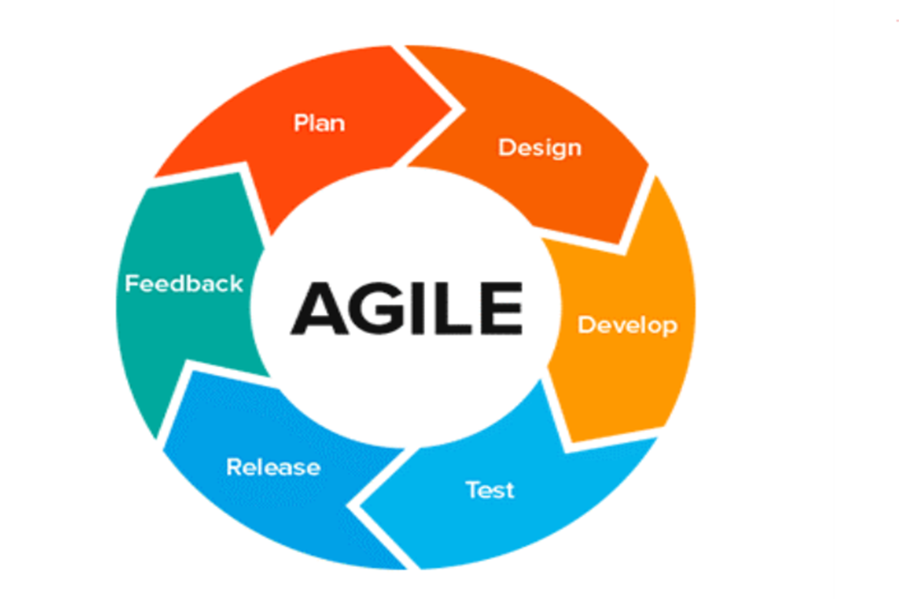

Figure Agile Development Methodology

Each cycle goes through the following processes:

*Planning*: New proposed requirements and feedback from the previous cycle are gathered and documented to create a list of formal requirements for the new cycle.

*Design*: New designs are made from the previous cycle to accommodate the new changes in requirements into the application. Develop: A prototype of the system is made while meeting the list of the requirements. The emphasis is on the speed of delivery and completeness of the product.

*Test*: The reality of the application is compared to the objectives set to evaluate if they have been met.

*Release*: The prototype of the solution is released for test use in the live environment.

*Feedback*: Input from prototype users and other stakeholders is collected.

In the planning stage of the project, the problem will be clearly defined. In this case, how to receive, handle, resolve and manage university students' complaints effectively. Research objectives will be set and met.

In the design stage of this project, the complaint management process will be clearly formulated. All the stages will be clearly identified and the procedures that are to be implemented in the stage developed. Test data for some complaints will be analyzed using the machine learning algorithms for named entity recognition and natural language generation.

In the development stage, the prototype of the system will be developed or improved. This will be a complete university student complaint management system with all the modules and functionalities. The machine learning algorithms will be incorporated into the system, and all the environment variables configured.

In the testing phase, a formal complaint will be logged into the system, and all the processes and procedures followed to resolve the complaint.

In the feedback stage, the feedback that was gathered in the testing stage will be analyzed to produce actionable requirements in the system. This way, the requirements can be implemented in the next cycle of development. The supervisor input will be taken into account in the next cycle of software development.

## 3.5 Justification for Methodology

Agile development model will be appropriate for development of this projects due to its interactive and iterative nature. Development will be based on stages and with the use of the model, I will always come back to a stage I already finished up if there occurs a change in the requirements i.e. iterative aspect.

The flexible nature of agile methods is the motivating factor to its usage. This allows changes to be made at any stage and the testing done after the iterations ensures you do not have to redo the whole system again. The many userinteractions and the developer teams ensures the final product satisfies the user’s needs.

## 3.6 Ethical Considerations

1. The research does not violate any state rule and is acceptable by many cultures especially the pastoral communities.
2. The technical requirements are a simple machine and an android phone which are readily available.
3. The data collected for this research will be analyzed and without any victimization.

# CHAPTER FOUR

# SYSTEM ANALYSIS AND DESIGN

## 4.1 Introduction

This chapter entails how the system is analyzed and designed. Feasibility analysis is discussed and it deals with the practical system to be implemented. In the design, the system is made easier for the user to promote friendly interaction during navigation.

## 4.2 Feasibility analysis

### 4.2.1 Technical Feasibility

This Feasibility simply answers the question, can we build it? The first technique in the feasibility analysis is to assess the technical feasibility of the project, the extent to which the system can be successfully designed, developed, and installed by the IT group. Technical feasibility analysis is, in essence, a technical risk analysis that strives to answer the question: “Can we build it?”

Familiarity with the technology is another important source of technical risk. When a system will use technology that has not been used before within the organization, there is a greater chance that problems and delays will occur because of the need to learn how to use the technology. Risk increases dramatically when the technology itself is new.

Project size is an important consideration, whether measured as the number of people on the development team, the length of time it will take to complete the project, or the number of distinct features in the system. Larger projects present more risk, because they are more complicated to manage and because there is a greater chance that some important system requirements will be overlooked or misunderstood. The extent to which the project is highly integrated with other systems can cause problems, because complexity is increased when many systems must work together.

Considering that this system is also based on an android application and some hardware components, it only requires a computer with all the required developments environments e.g., Android studio and database hosting etc. Therefore, the system is technically viable.

### 4.2.2 Economic Feasibility

The refers to the economic value of the system to the business setup that is will it provide business value? The second element of a feasibility analysis is to perform an economic feasibility analysis. This attempts to answer the question “Should we build the system?” Economic feasibility is determined by identifying costs and benefits associated with the system, assigning values to them, calculating future cash flows, and measuring the financial worthiness of the project. The more expensive the project, the more rigorous and detailed the analysis should be.

In this study economic feasibility is aimed at determination of whether or not to continue with the project, depending on whether the project is economically viable. This system is within affordable budget limits since it is not very complex. Since all the required resources are at access with ease, the system will be economically viable.

### 4.2.3 Scheduling Feasibility

This feasibility answers the question of time. Can the project be finished at a given particular time limit? It evaluates whether the proposed system will be completed within the specified time limits and be implemented. Due to the available requirements, this project will be finished within the stipulated time.

### 4.2.4 Operational Feasibility

It measures how well a problem will be solved and evaluation of how opportunities present will be taken advantage of within the timescale to deliver what is required by the customers. In this study operational feasibility is aimed at determining whether and how well the customer needs will be met by completing the project. It also examines how a project plan satisfies the requirements identified in the requirements analysis phase of the system development. Since all the requirements are identified, the system will be operational viable.

## 4.3 Requirement Analysis

By definition, “Requirement Analysis is the process of developing software specification that are intended to communicate the system needs of the customer to the system developers. (Ian Somerville, Software Engineering, 9th edition).

The term “Requirement” is not consistently used in the software industry. In some cases, a requirement is simply a high-level, abstract statement of a service that a system should provide or a constraint on a system. Software system requirements are often classified as functional and nonfunctional requirements.

### 4.3.1 Functional Requirements

These are functionalities or operations that the system must perform. In this system the following will be functionalities in the user section. For this case, the user is the farmer

1. Farmer inserts soil moisture sensor to the soil.
2. Farmer checks the soil moisture level in the soil.
3. Farmer chooses to manually turn on water pumps.

### 4.3.2 Non-Functional Requirements

1. **Speed -**Be fast in terms of response time.
2. **Ease of use-** Be learnable and easy to use for all type of users.
3. **Reliability-** Minimum meantime to failure, low probability of unavailability and rate of failure occurrence. It should be available at all times.

## 4.4 Data Analysis

### 4.4.1 Questionnaire

This consists of a series of questions for the purpose of gathering information from respondents.

I have conducted a questionnaire and below are the out comes of it

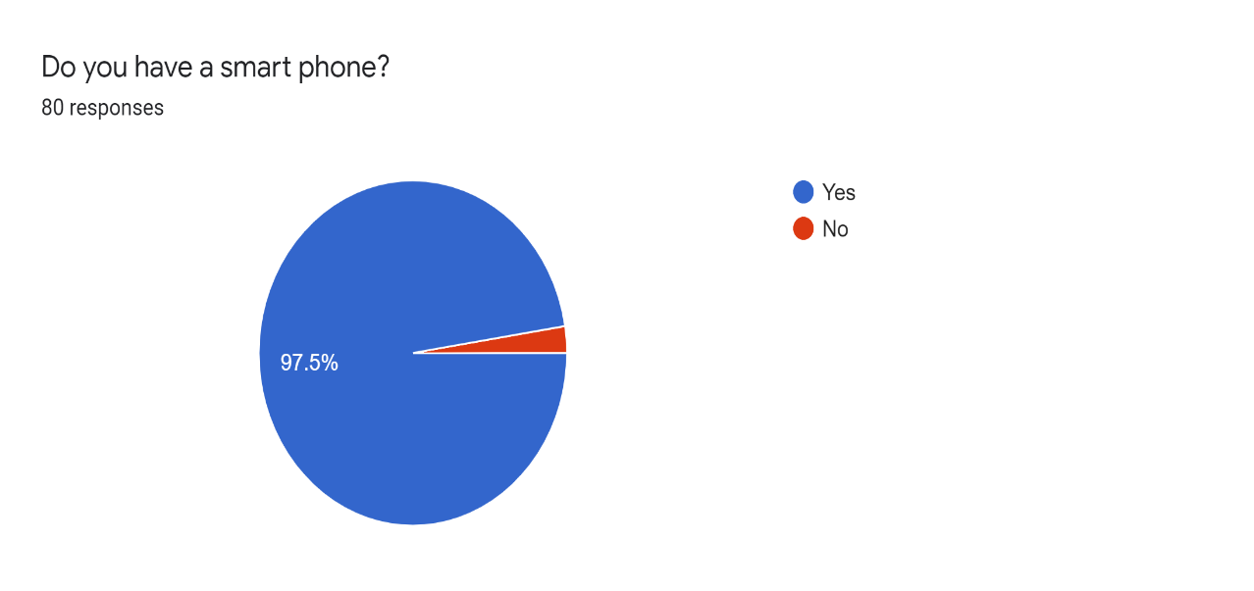

Figure Questionnaire 1

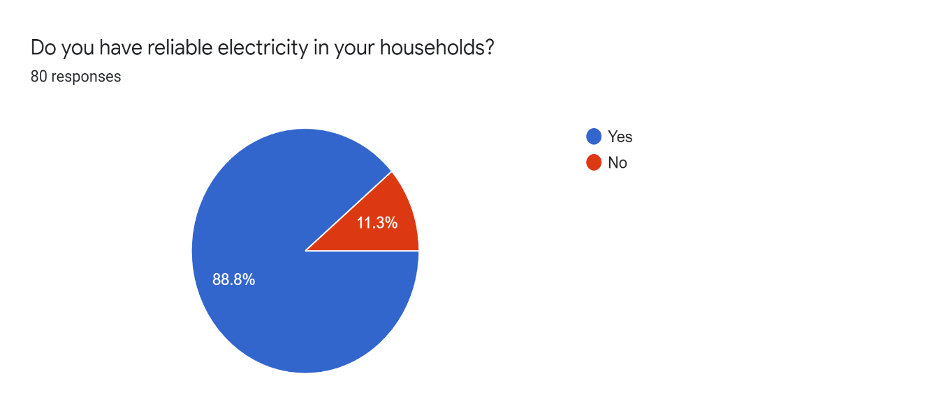

Figure Questionnaire 2

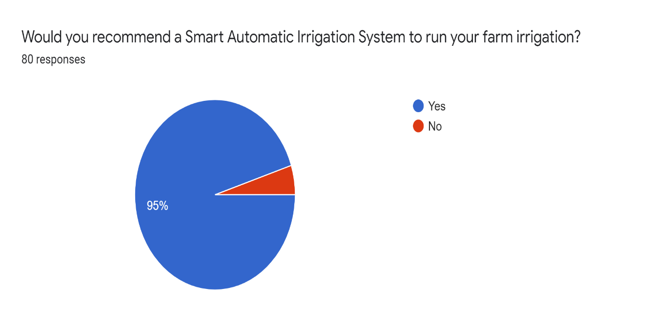

Figure Figure 4 Questionnaire 3

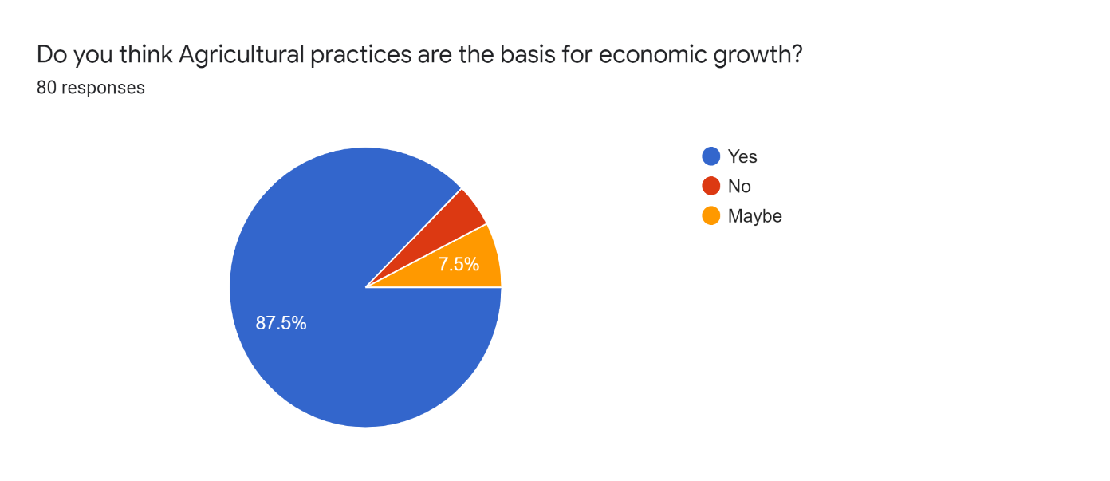

Figure Figure 4 Questionnaire 4

## 4.5 Design

### 4.5.1 Flow Chart



Figure Flow Chart

### 4.5.2 Block Diagram

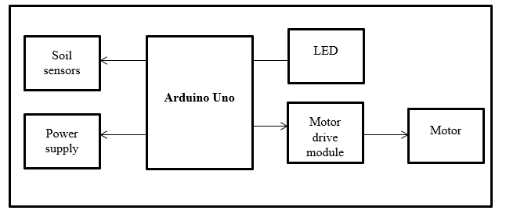

Figure Block Diagram

### Sequential Diagram

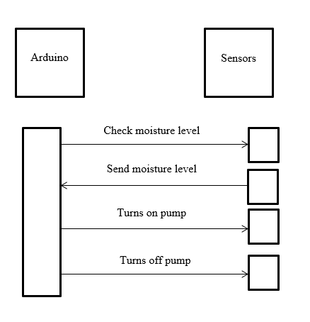

Figure Sequential Diagram

### 4.5.4 Data Flow Diagram(DFD)

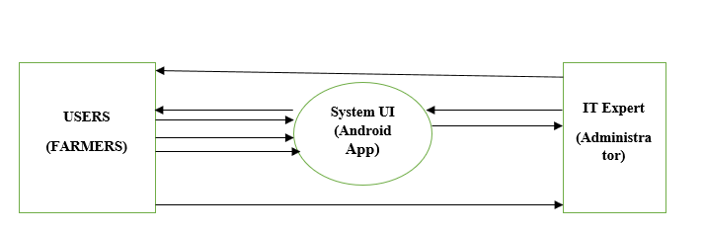

Figure Data Flow Diagram

**Users**: select ports, select the mode (switch to manual), notify admin of the errors

**System UI**: show date, time, pump status and moisture percentage.

**IT Expert:** notify the user about the updates, correct errors.

### 4.5.5 Use case Diagram

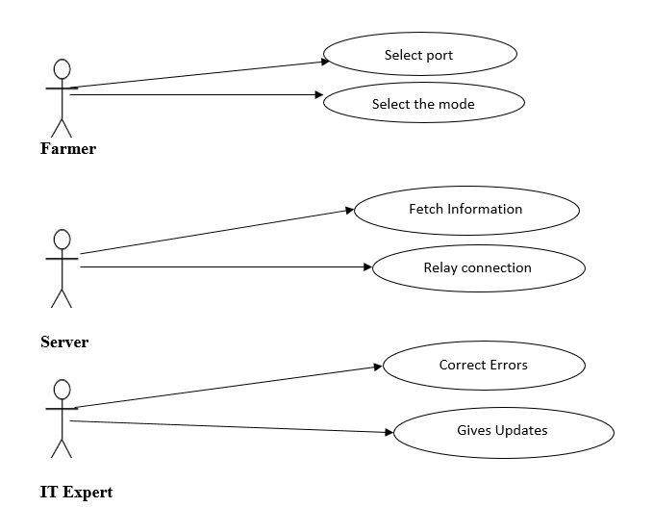

Figure Use Case Diagram

### 4.5.6 Circuit Diagram

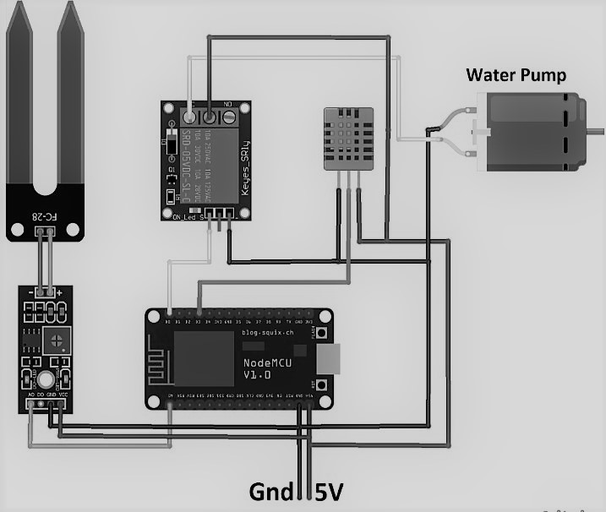

Figure Circuit Diagram

# CHAPTER FIVE

# SYSTEM IMPLEMENTATION AND TESTING

## 5.1 Introduction

This chapter entails testing, implementation and deployment activities for this system. System design involves the determination of how to build the system and its overall architecture to serve as a technical system blueprint. Deployment then refers to activities that make the hardware and software available for use. Software Testing on the other hand is a strategy that integrates test case design methods into a well-planned series of steps that result in the successful construction of software.

## 5.2 System Test Plan

System test plan is one of the first things that should happen in software testing. System test plans outline the process of testing the functionality of the software and systems as well as describes the approach, objectives, resources, schedule and scope of a software testing effort.

## 5.3 Test Plan

Test Plan in software and system testing is the document that outlines the who, what, when, and how to do a testing of a project.

### 5.3.1 Unit Testing

In this system, this testing Involves examining the minimal software components and subcomponents or modules such as the turning on and off water pumps, reading soil moisture among other modules. Each module was tested individually to verify that they function correctly as per the content. For instance, a module like checking moisture level in the soil was tested to see whether it carried out the full process correctly.

### 5.3.2 Integration Testing

In this stage, different modules of the system were combined together and tested as a whole. In this process, it verified that the individual components integrated were able to work together and interact well without any conflicts. It was tested that the integrated modules were able to meet the stated user needs.

### 5.3.3 Acceptance Testing

In this stage of testing, activities involved taking the final system to the real users of the system to test the system for themselves. After the testing it was found that the system had good usability and could be easily understood even by people with little computing knowledge.

## 5.4 Test Cases

A test case is a set of conditions or variables under which a tester will determine whether a system under test satisfies requirements or works correctly. This is a process which involved a series of different kinds of tests performed on the system and its components. The process of developing test cases can also help find problems in the requirements.

### 5.4.1 Automatic Page

This is the automatic page of the application interface which shows the time of the day, date, pump status and the percentage of the moisture content.

The initial percentage should be zero as shown below:

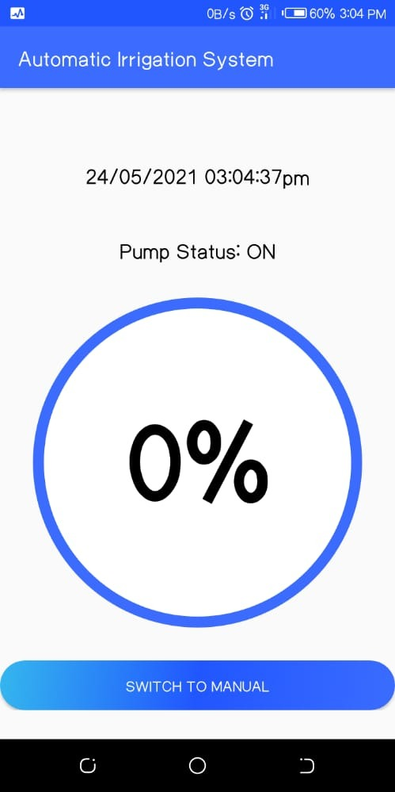

Figure Automatic Page

### 5.4.2 Manual Page

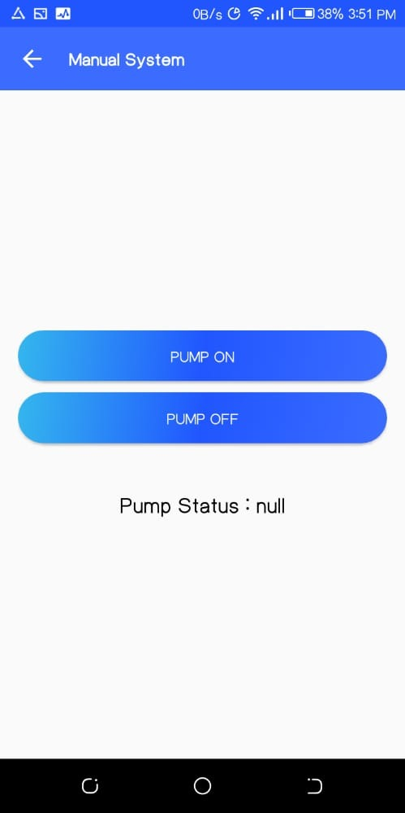

Figure Manual Page

## 5.5 System Implementation

This is the process of defining how the information system should be built (i.e., physical system design), ensuring that the information system is operational and used, ensuring that the information system meets quality standard (i.e., quality assurance).

### 5.5.1 Collection of data

The information concerning people’s irrigation process has to be converted into data that will be ready for use in the new automated system. This will require the computerization of manual work that require farmers to be in the farm.

### 5.5.2 Implementation Strategy

Having the requirements being quite clear. I started on the implementation of the findings. It is in this stage that I did acquire and developed the programs that will help meet the expectations of the system. Moreover, I developed interfaces that will enable farmers interact with their irrigation process as show in the test case diagrams above.

# REFERENCES

Understanding the Agile Software Development Lifecycle and Process Workflow. (2019). Retrieved from <https://www.smartsheet.com/understanding-agile-software-development-lifecycle-and-process-workflow>

Data Collection Methods - Research-Methodology. (2019). Retrieved from <https://research-methodology.net/research-methods/data-collection/>

Moller, J. (2010). A Versatile Technology in automation of agriculture machinery. Computer vision, 17.

Drip and Micro Irrigation Design and Management for Trees, Vines, and Field Crops, 5th Edition, by Charles M. Burt and Stuart W. Styles, published by the Irrigation-Training and Research-Center (ITRC), Cal Poly, San Luis Obispo, CA 93407–0721. [www.itrc.org](http://www.itrc.org) , (2016)

Irrigation, 5th Edition, Muhammad Irfan Khan Yousafzai, Claude H. Pair, editor, published by the Irrigation Association, (1983)

A solution to water management in agriculture- By Stéphanie Roblin (2016). Retrieved from <http://www.renewableenergyfocus.com/view/44586/solar-powered-irrigation-a-solution-to-water-management-in-agriculture/>

Vagulabranan, R., Karthikeyan, M., & Sasikala, V. (2016). Automatic Irrigation System on Sensing Soil Moisture Content. International Research Journal of Engineering and Technology (IRJET), 3.

Scribd. (2017). Automatic Irrigation System on Sensing Soil Moisture Content | Irrigation | Soil. [online] Available at: <https://www.scribd.com/document/362464538/Automatic-Irrigation-System-onSensing-Soil-Moisture-Content>.

Moller, J. (2010). A Versatile Technology in automation of agriculture machinery. Computer virsion, 17.

# APPENDICES

## A.1 RESOURCES

1. Laptop/Desktop PC
2. Arduino
3. Server
4. Smart phone/mobile phone
5. Android studio IDE
6. GSM module/modem
7. DC motor
8. PIC16F877 Microcontroller
9. Soil-Moisture sensor

## A.2 SCHEDULE

|  |  |  |
| --- | --- | --- |
| **Descriptions** | Duration | Deliverables |
| Problem Definition and Research | Jan-March | Requirement Specification Document |
| System Design | March-April | System Design Documentation |
| Classification Model Development and Training | April | System Design Documentation |
| System Development & Testing and refinement | April-May | Automated system (automatic-manual-triggered) |
| User Interface Refinement and Interoperability Testing & Presentation and deployment | June-July | Automated Irrigation system relevance |

*Table 1. Time Schedule for the project*

**Time Schedule Gannt Chart**

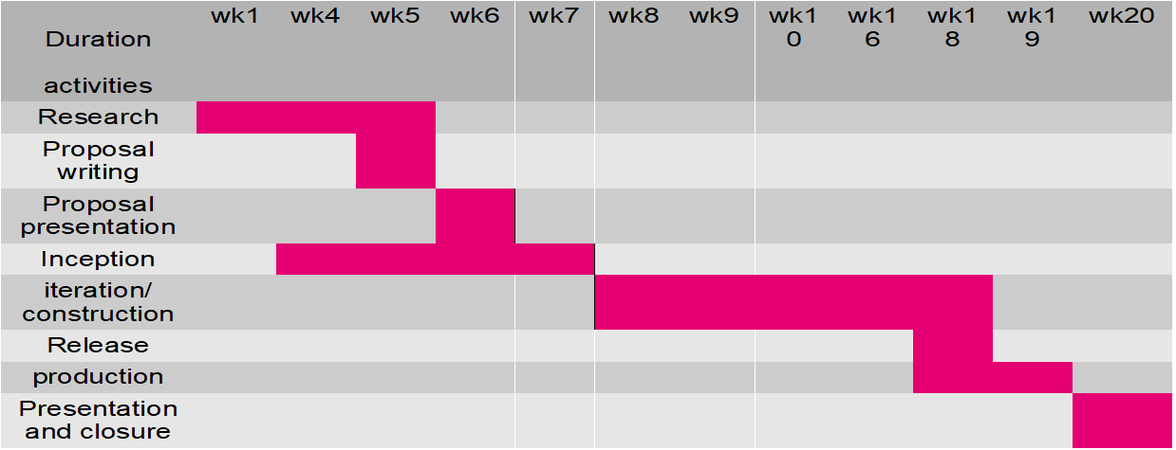

*Table 2 Gannt Chart*

## A.3 BUDGET

|  |  |
| --- | --- |
| ITEM(S) | BUDGET |
| Laptop | 40,000 |
| Internet Connection | 1,000 |
| Android Device | 10,000 |
| Electricity | 500 |
| GSM Module | 3,000 |
| Arduino | 1,200 |
| Dc motor | 800 |
| Sensor/connecting wires | 1,200 |

*Table 3 Budget*